Evaluation Report of the EU-China IPR2 mediation and information service at trade fairs
by Wu Zhuomin

May 2011

Purpose and Range of the Evaluation

The aim of this report is to comprehensively evaluate the result of the mediation service at German trade fairs, for which EU-China IPR2 Project has provided IP support on site. The reference data of the evaluation will be firstly collected from previous management reports and the case reviews; thereafter the collected data will be analyzed and displayed in MS Excel, which could be used as a basic database for the mediation results and is easily extendable for the future mediation, as long as the future mediator would accomplish the case record in the form of the sample case record for CeBIT 2011.

The aforementioned data regards to all Mediation and Information Cases at the German trade fairs, for which the Mediation Service has been provided, i.e. CeBIT 2009/2010/2011 (Hannover), Industriemesse 2009/2010/2011 (Hanover), IFA 2009/2010 (Berlin), Schweissen & Schneiden 2009 (Essen), Light & Achitechture 2010 (Frankfurt). From March 2009 to May 2011 the service has been provided ten times for these trade fairs.

Basic and variable data

The number of exhibitors is usually calculated by trade fair organizers and is searchable on its official websites. However, the accurate exhibitor numbers disclosed by the internet database could be slightly different from the numbers indicated by co-organizers. This report only adopts the data indicated in the official database, or the data disclosed by the trade fair organizers. In 2009 fewer exhibitors were able to come to the exhibition because of volcanic eruption in Iceland, even if they had already registered in the database. In this case, we only account the present exhibitors which indicated by co-organizers. However, this number might differ from the real number of the exhibitors.

Furthermore, there was no record for the number of exhibitors at Industriemesse 2009. According to the official report of Industriemesse 2011, the number has been increased 30% than 2009. To proceed further calculation of the statistic, we calculate the number of Industriemesse 2009 analog the rate indicated in 2011, namely 270 exhibitors.

Regarding the number of mediation cases, it is necessary to point out that not all of the IP disputes at the aforementioned trade fairs have been settled by mediation service, since the service is unbidden. Some exhibitors might solve the IP problems by their own means. However, according to the feedback from the co-organizers and exhibitors, most of the IP disputes have been handled by mediation service, only a few exhibitors, which did not informed about the service, have handled the disputes without the mediation support. Thus, the statistic of the mediation service is able to represent the real situation of IP disputes at the trade fairs.

Macroscopic Evaluation of the Mediation & Information Service

From 2009 to 2011 there were totally 209 mediation and information cases at the aforementioned trade fairs in Hannover, Berlin, Frankfurt and Essen. CeBIT and IFA are the most active trade fairs where there were more IP disputes, as shown in the left diagram. These trade fairs are professional trade fairs for consumer electronic products.
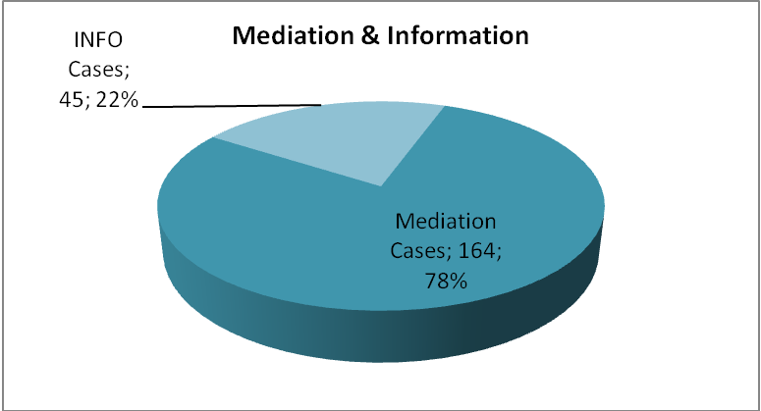
78.5% cases were mediation cases, and 45 21.6% were information cases. Mediation cases refers to IP disputes in the form of warning letter, preliminary injunction, civil law suit, enforcement of civil court decision or criminal complaint. Information cases are the cases, in which mediator only provided information service, for example IP protection in Europe, Germany and China, etc. Therefore, to make the analysis of IP disputes at trade fair, we have to focus on the statistic of mediation cases.
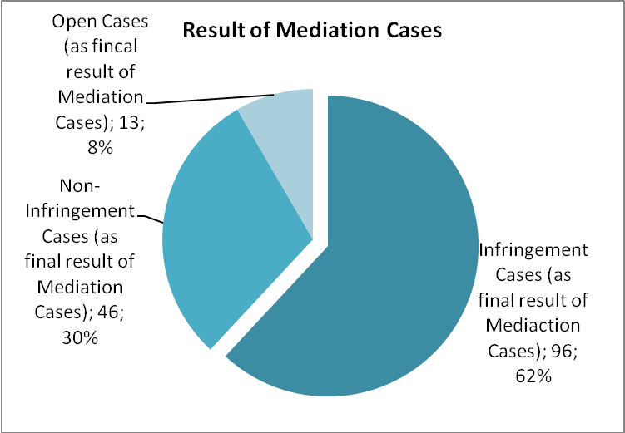
The diagram left shows that 62% of mediation cases have been confirmed as infringement cases, which means that the involved Chinese exhibitors have infringed the IP rights. 30% of mediation cases have been closed without IP infringement. 8% were open, this means that the result was not clear or the parties were in progress of negotiation, so that we could not judge whether the infringement has been established or not during the trade fairs.

At the aforementioned ten trade fairs there were approximately 2837 exhibitors coming from Mainland China. Considering the frequency of IP disputes in which Chinese exhibitors have been involved in: every 17 Chinese exhibitors have been involved in an IP dispute; and there would be one infringer in every 29 Chinese exhibitors. However, among the mediation cases there were some exhibitors from Hong Kong and Taiwan. Some exhibitors have been even involved in different mediation cases. If without counting the parties from Hong Kong and Taiwan, and without double counting of the same exhibitors involved in different cases, the frequency of IP disputes of Mainland Chinese exhibitors shall be even lower.
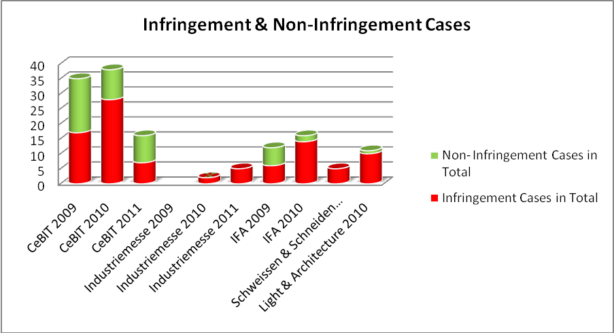
The percentage of the infringement of mediation cases differs from trade fair to trade fair, for example, approximately 41% of mediation cases at CeBIT (from 2009 to 2011) were closed with IP infringement; at IFA (from 2009 to 2010) the percentage of infringement was relatively higher, about 53%. Different than CeBIT and IFA, the highest rate of infringement was at Light & Architecture 2010, about 91%.

To have an overview of the long term effect of the mediation service we would like to take CeBIT as an example, since the service has been provided in 2009, 2010 and 2011. This trade fair is a typical trade fair for Chinese exhibitors, at which the competition from China has become more and more strong, so that more disputes regarding to patent infringement has been raised.

After the serious enforcement activities against Chinese exhibitors in 2008 (such as criminal complaints, see the red line on the left side), the number of Chinese exhibitors has been rapidly decreased from 466 to 314 in 2009 (see the blue line). The number of enforcement cases (criminal complaints) in 2009 has not been obviously decreased, even there were much fewer exhibitors. On one hand, this indicates that IP disputes at CeBIT 2009 were relatively more than last year; on the other hand, it shows that the European right holders were taking more legal actions against products pirates from China.

Establishing the mediation service at CeBIT in 2009 was exactly the right time. With the support of mediation station Chinese exhibitors began to understand the IP legal situation in Germany and know how to react legally and reasonably. As a visible result the numbers of enforcement and mediation cases in 2010 have been clearly decreased. Meanwhile, the number of exhibitors has been recovered step by step. Up to 2011 the number of exhibitors is almost as much as in 2008, and the IP disputes keeps reducing.

The number of IP disputes has been decreased stably at CeBIT since 2009. The number of enforcement cases has been decreased from 46 to 8; and mediation cases have been reduced from 42 to 17. The decreasing trend of the IP disputes shows a positive development of IP support to exhibitors and right holders. The mediation & information service does not only help parties to solve disputes onsite, but also helps Chinese exhibitors to understand and respect IPR. At the same time, they also learned how to protect their own rights at German trade fairs.

Microcosmic Evaluation of Mediation Cases

To have a better understanding about the IP disputes at trade fair, we have to make a closer observation at case statistic in detail.

As shown in the diagram left, 52% of 164 mediation cases were criminal complaints; 26% were civil warning letters and 14% were preliminary injunctions. The proportion of the civil law suit was relative low, merely 4%. The last category of mediation cases, in which German bailiffs were involved in because of the enforcement of civil court decision, was accounted for 5%.

The most used legal measure, criminal complaint, has been mainly used at CeBIT, IFA and Light & Architecture. The left diagram indicates that the number of criminal complaints at CeBIT has been decreased from 2009 to 2011. However, this is not the case for IFA. We would need the data for IFA 2011 in September, so that an estimation would be possible.

Criminal complaints at CeBIT and IFA were mainly issued by serveral European right holders and its representatives. Wehter they have been succssfully supported after the investigation proceeded by state prosecutors could be clearly seen in the diagram on the right side. 54% of 82 criminal complaints have been confirmed as infringement cases in the end. However, 46% of the complaints have not been supported, since there was no infringement.

The diagram underneath shows us the rate of infringement in criminal cases at each trade fair. At Light & Architecture 2010 and IFA 2010 the rate of infringement were much higher than at CeBIT (see the red columns).
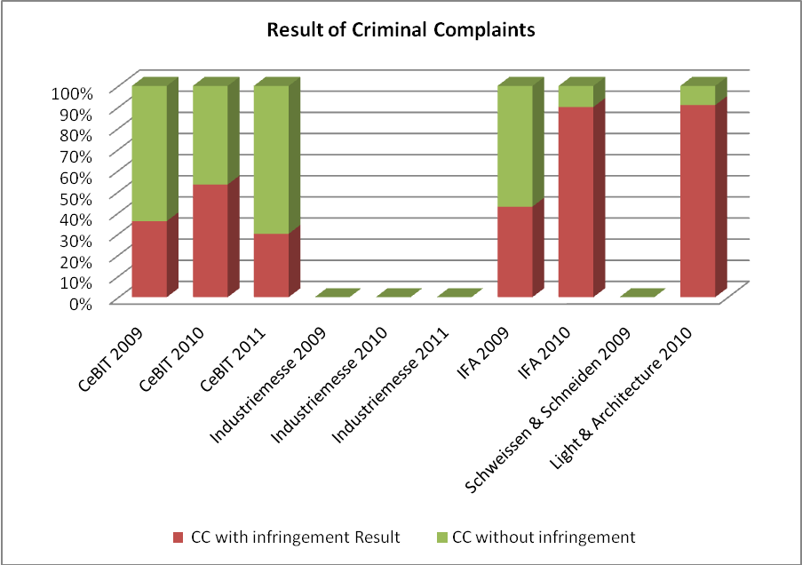

Regarding the IP disputes in the frame of civil law, the rate of infringement was higher than criminal cases, reached 84%. Merely 16% civil cases have been confirmed as non-infringement in the end.

In civil cases, warning letter is the most used measure against product pirates.

We can see this from the left diagram, on which the blue columns were the majority at almost every trade fair. Preliminary injunctions are relative fewer. Law suits have been only raised at CeBIT and IFA.

At CeBIT and IFA right holders such as Siemens, Philips, Apple and SISVEL are in particular active. Most of the criminal complaints were issued by SISVEL for suing patent infringement of MPEG and DVB-T technology. Apple was particular active for protecting their designs and trademark for products such as iPod, iPhone, by sending civil warning letters or applying for preliminary injunctions.
In the 164 mediation cases, 60% were related to patent infringement; 27% were about industrial design protection. Trade mark cases were about 10%. There were few cases of copyright and utility model, merely 2% and 1%.

To be more precise, patent disputes are the majority at CeBIT and IFA. Nevertheless, for Industriemesse and Light & Architecture trademark and design disputes played more important role (see the purple and green columns down under).

SUGGESTIONS

- Mediators from CCPIT should be systematically trained in IP.
- All mediators should update their knowledge on IP, in particular the new German court decisions regarding to the IP infringement at trade fairs.
- Mediators and Mediation team should keep close contact with the state prosecutor in Hannover, since the trust between the prosecutor and mediator would directly affect the cooperation.
- During the mediation service mediators shall not advise exhibitors to make negative reactions without the careful consideration of substantial legal problems, since the new court decisions and the situation of indirect infringement has been recently changed in the direction, which would be an advantage for Chinese exhibitors.
- Mediators should have the necessary knowledge to make basic IP search in the related database on site.
- Mediators should be able to clearly and accurately summarize the claims and opposite opinions. Furthermore, the related information shall be carefully recorded in the case record.
- At meetings with enforcement leaders such as prosecutor or police officer, it is better to have efficient and direct conversation regarding to the mediation work itself, instead of staying at diplomatic level.
- As necessary exchange of the result of the cooperation, mediator or the mediation team may deliver a statistic report to partners such as state prosecutor, police, custom and trade fair organizer.
- It is recommendable to make the information service available before and after trade fair, probably as a permanent service, so that exhibitors could have better chance to solve the problems before they go abroad.
- Training Program for companies in Shenzhen should be upgraded to a higher level. Many companies in Shenzhen have already had IP issues and need more guidance for trade fair practice.
- Training Program for companies in south west China like Chengdu should be provided continuously, since these companies are getting the first touch with oversea IP issues. In comparison with Shenzhen, they need more basic training.

