Offline Event: How Legal People See "Medicine God" : "Dying to Survive " in the Eyes of IP Professionals

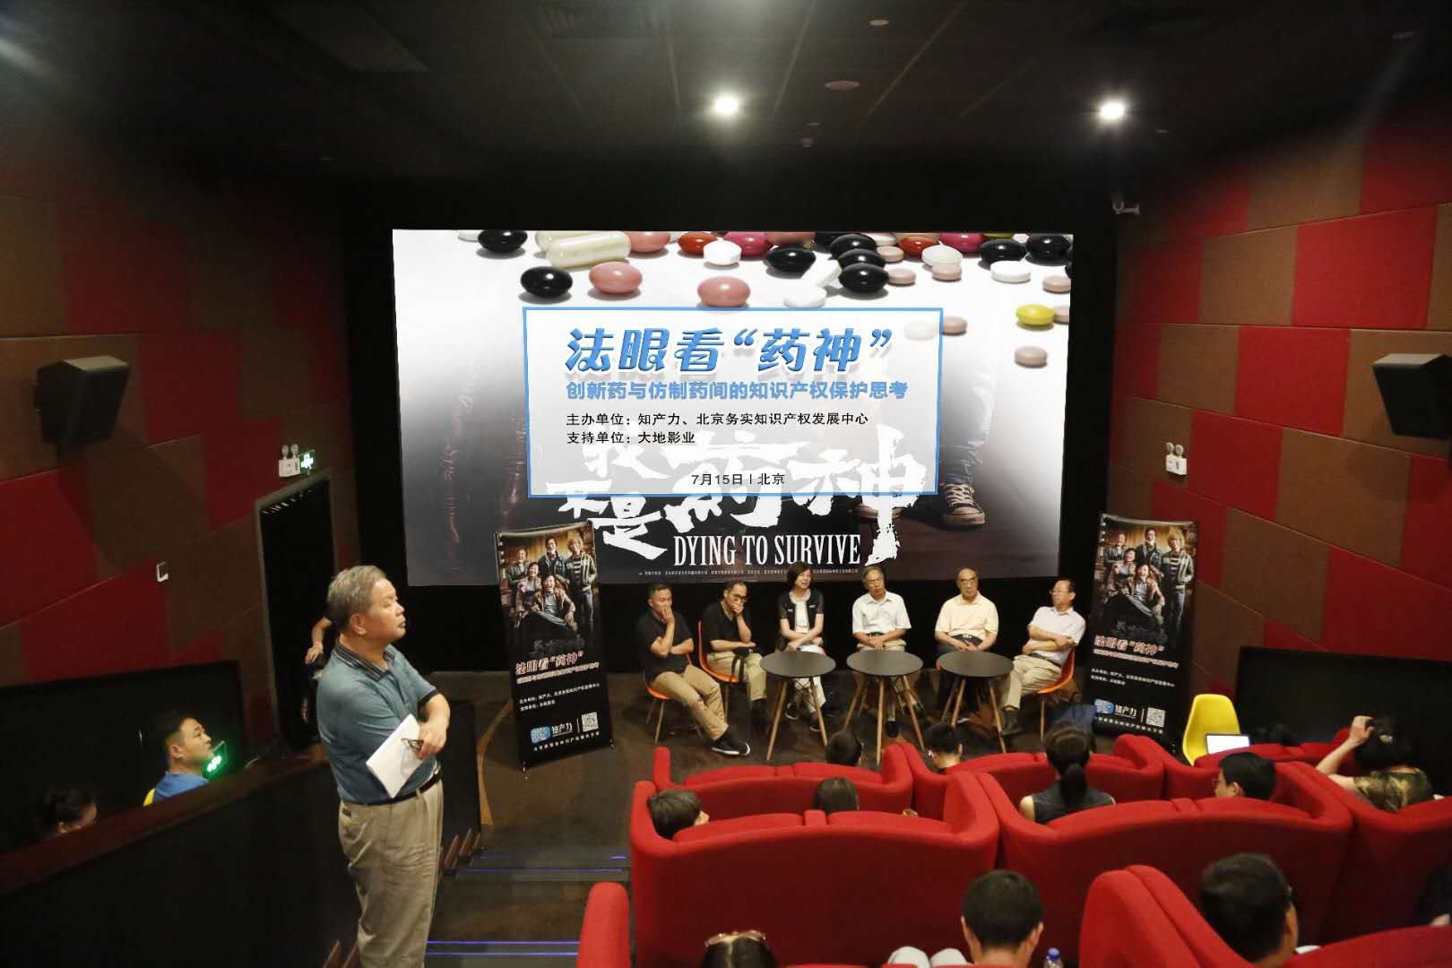

Recently, the movie "I am not a drug god" detonated the public's craze for movies. In the film, the cancer patient group was unable to pay the price of the original drug and turned to buy the lower-priced generic drug from the “drug dealer” Cheng Yong (prototype Lu Yong), which revealed the reality of the helplessness of many cancer patients. In the pharmaceutical industry's view, the social phenomenon of expensive drug prices reflected in the film involves not only the issue of drug patent and administrative examination and approval systems, but also many factors such as the balance of interests between innovative pharmaceutical companies and generic drug companies and patients.

On July 15th, Beijing IP House and Beijing Intellectual Property Institute (BIPI) jointly held an event in Beijing to watch and discuss about the movie “Dying to Survive”. People attending the event include judges, patent examiners, university scholars, lawyers and representatives of pharmaceutical companies, who exchanged views on innovative drugs and generic drugs, intellectual property protection hotspots and difficult issues.

It is reported that some of the guests present were not watching the film for the first time, but they were still shocked and moved by the stories told in the film.
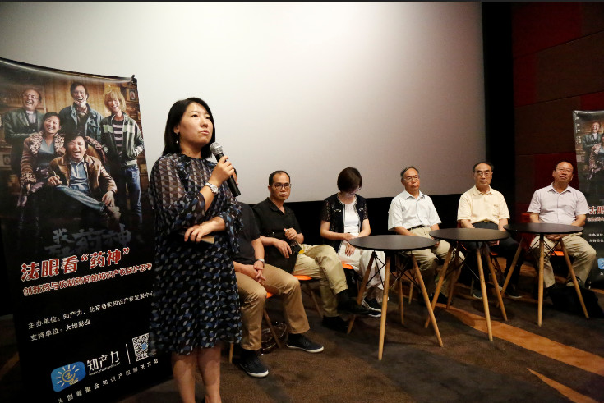

At the beginning of the discussion, Ms. Zhao Dong, deputy general manager of Nanhai Holdings, a group owned by Dadi Cinema, first delivered a speech. Ms. Zhao Dong said that changing the world with knowledge and heart is the mission of the Nanhai Group. Knowledge is an important element. From a certain point of view, intellectual property rights are very compatible with the mission of the Nanhai Holdings Group. She thanked the IP House and BIPI for their trust in the Land Theater, and hoped cooperation will continue in all aspects of the intellectual property field in the future.

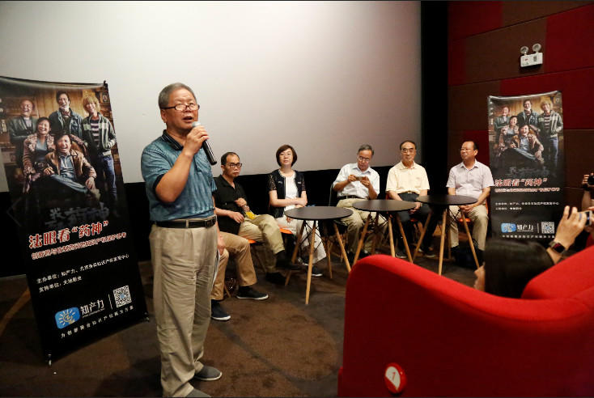

The discussion session was hosted by Director Cheng Yongshun of BIPI.
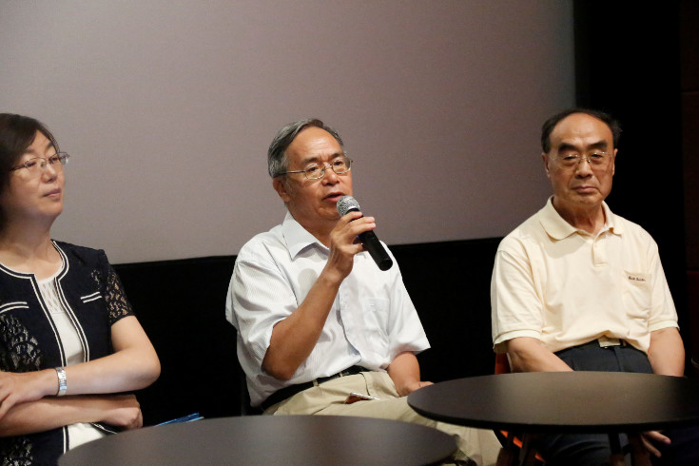

Mr. Zhang Qingkui, chairman of the Pharmaceutical Intellectual Property Research Committee of China Pharmaceutical Association said that as a special commodity, the state has introduced a series of supporting policies in drug registration, approval and management. The development of innovative drugs has gone through a process from scratch, and encouraging innovation requires a patent system. Innovative drugs are the foundation of generic drugs. Without innovation, there is no medicine to eat, let alone the problem of imitation. In addition, it is necessary to clarify a basic concept: What is a counterfeit drug? In the eyes of ordinary people, fake drugs are just like the fake and shoddy goods we usually say, but it is not. All drugs that are in violation of the relevant provisions of the Drug Administration Law, and that have not been approved by the drug regulatory authority are defined as counterfeit drugs even if the efficacy is good.

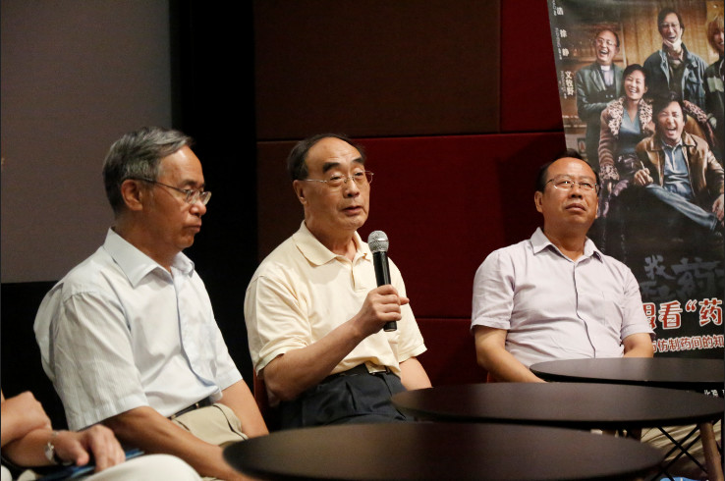

Professor Li Shunde from the University of Chinese Academy of Sciences also said that without patent protection, the development of new drugs is difficult to implement. The research and development cost of medicines is high, and it takes more than ten years or even decades. In addition, there are still many intermediate costs in the stage of drug marketing, so the price of medicines is reasonable. The pharmaceutical factory is not a non-profit organization. It is not realistic to let the pharmaceutical company reduce the price at a loss. It can reduce its cost from the operating mechanism. Patent compulsory licenses have clear provisions in the Paris Convention, and international consensus has been reached, but there are very few implementation cases. Patent compulsory licensing is a "double-edged sword" that is the result of a balance of interests. The TRIPS Agreement has made very detailed and specific regulations on the implementation of restrictions on compulsory licenses, which need to be paid enough attention.

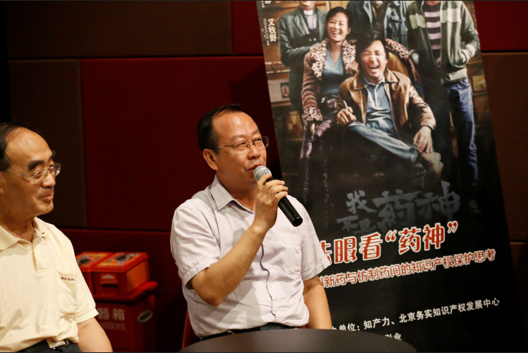

Mr. Cheng Yonghao, the director and researcher of the Institute of Materia Medica of the Chinese Academy of Medical Sciences, said that the appeal of film art is shocking, but the legal issues reflected in the film are thought-provoking. From 2015 to now, China's drug review and approval system has undergone tremendous changes, and encouraging innovation is essential for drug patent protection. China has a large population base and medical insurance is not enough to solve the problem of accessibility of innovative drugs. We can try to supplement commercial insurance to encourage support for innovation to meet clinical needs.

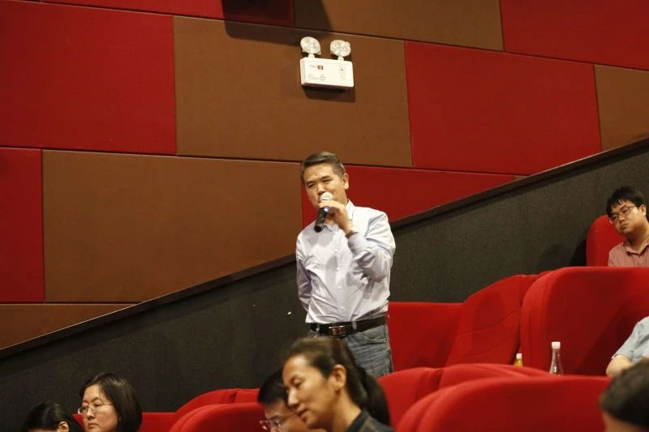

Professor Zhang Guangliang from the Intellectual Property College of Renmin University of China pointed out that the patent protection system is equally important for the original research drug and generic drug companies. In practice, some drug patents and infringement cases have a long trial period, which has led to a delay in the process of listing generic drugs. In view of the close correlation between pharmaceutical patents and public health, it is recommended that administrative agencies and judicial organs should give priority to trials of drug patents and infringement cases. The investment in research and development of new drugs is high and the risks are high. Therefore, the interests of patent holders of drugs should be fully protected. At the same time, the exercise of patent rights should be exercised according to the law, and the abuse of rights or even illegal monopoly behavior should be imposed.

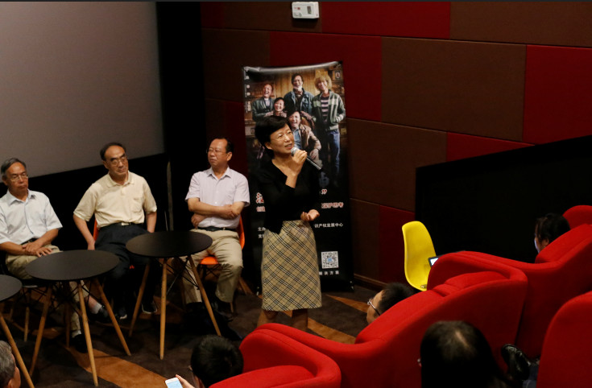

Ms. Guo Hua, the patent director of Novo Nordisk China Pharmaceuticals, expressed her feelings from the perspective of corporate practice. She pointed out that for high-risk R&D investment and possible return of innovative pharmaceutical companies, patents are almost the only effective protection method and the “lifeline” of enterprises. At present, the competition in the field of medicine is becoming increasingly fierce. Generally, in the laboratory stage, enterprises will submit patent applications for compounds to open a 20-year patent protection period; while drugs can be found from targets, design molecules, clinical trials, and drug supervision. It takes at least 10 years for the bureau to approve the registration. After obtaining the approval of the Food and Drug Administration, it is also necessary to participate in the bidding and hospitalization of the provinces in order to finally benefit the patients. Many links take a long time. In some cases, after the drug enters the medical insurance, the compound patent may expire immediately, so that the original drug will face the market competition of generic drugs soon after the sales growth.

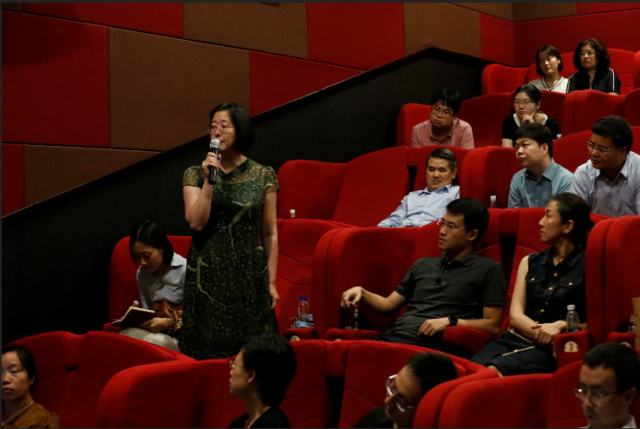

Ms. Qi Wenjun, Director of Intellectual Property of Zhengda Tianqing, said that patents are only part of the reason for the social phenomenon of high-priced drugs. In addition, it is also due to reasons such as the level of pharmaceutical research and the length of the approval process. The timely inclusion of health insurance after the listing of a patented drug may be a solution. At present, there is no patent cliff in China. However, compared with more than 20 years ago, China's drug research and development level has been greatly improved. China's API products are now available all over the world, and preparation products are also being introduced to the international market. In the case that China's innovative drug research and development level has been able to integrate with the world, it is necessary to further strengthen innovation protection. In addition, innovative research and development for orphan drugs and rare diseases requires innovative protection policies.

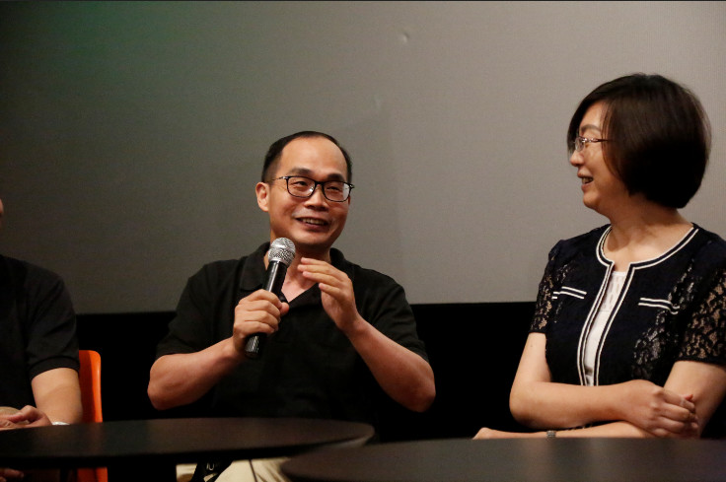

Mr. Li Renjiu, Director of Intellectual Property of Luye Pharmaceutical Group, said that no new drugs will be listed without patent protection. But patent protection can't be excessive. At present, there are opinions that the current patent examination in China is too demanding on the disclosure of experimental data. In fact, in the judgment of the invalidity of patent and patent infringement made by the New Jersey court in the United States last year, the experimental data for the specification is also highly demanded, which also shows that China The review criteria for the disclosure of experimental data is reasonable. The creativity judgment of innovative medicine patents is the same as the examination standards in other fields. If it meets the creativity requirements, it should naturally be recognized, but it cannot be considered that the patent (application) involving innovative drugs is necessarily creative. Creative or not should be determined in accordance with the instructions and inspiration given by the whole technology.

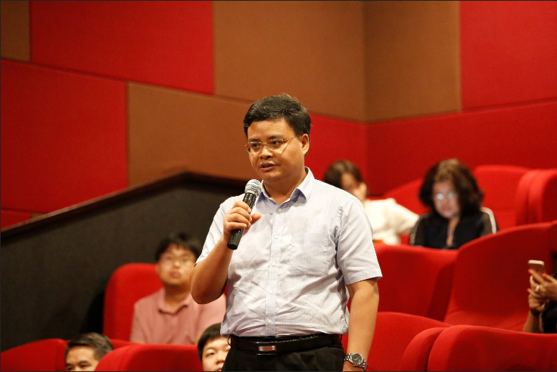

Mr. Liu Qinghui, a partner of Anjie Law Firm and former judge of the Beijing Higher People's Court, said that the film finally mentioned that in 2002, the cure rate of chronic myeloid leukemia in China was only 30%, and it increased to 85% in 2018. Behind the dramatic increase in the cure rate of the disease is the contribution of innovative medicines, so adequate protection is needed for innovative medicines. However, while protecting innovative drugs, it is necessary to consider the people's tolerance for drug prices. The pricing of innovative drugs still needs to be further explored.

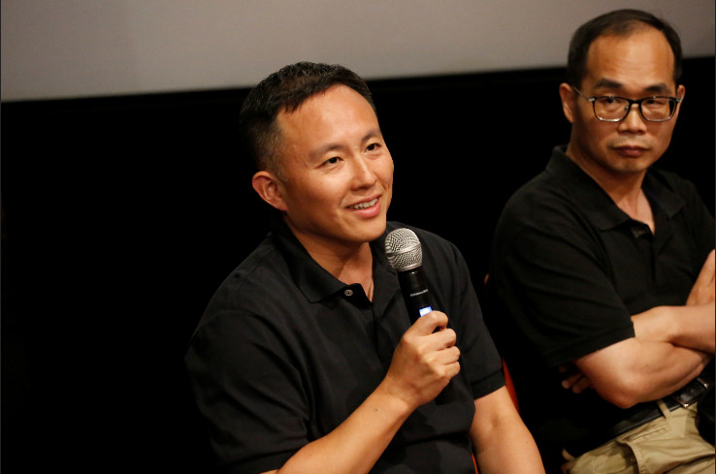

Mr. He Jing, a partner of Anjie Law Firm, asked a question, Do the investors of the film dare to invest in new drug development? He said that in the movie, the scene about Mr. Lu Shouyi’s wife proposing a toast to Cheng Yong was very touching. In her mind, Cheng Yong is a hero. To IP professionals like us, the person who developed the new drug is also a hero. We need to make these heroes as useful as possible. Heroes may be "arrogant" and make mistakes, but this is not a concern in our intellectual property field. The price and quality of drugs need to be regulated by other departmental laws. Intellectual property rights are created for innovation.

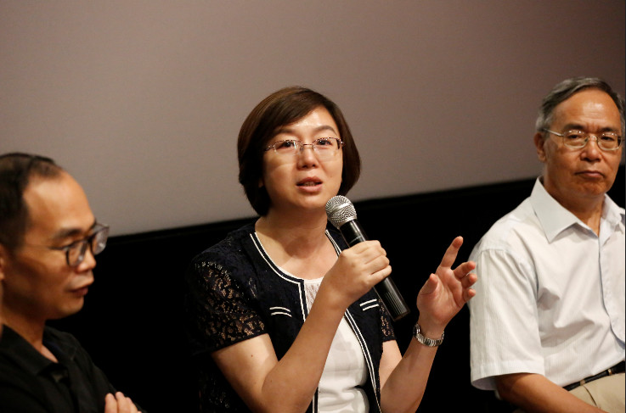

Judge Jiang Ying of the Beijing Intellectual Property Court said that the cost of research and development of innovative pharmaceutical companies is high and that patent protection is needed to give innovation. Pharmaceutical companies are not philanthropists and need to be profitable, but whether they should also bear certain social responsibilities needs to be further explored. For innovative pharmaceutical companies, speeding up the approval process and shortening the time limit for refusal or invalidation can provide longer and more effective protection for truly valuable drugs to a certain extent.

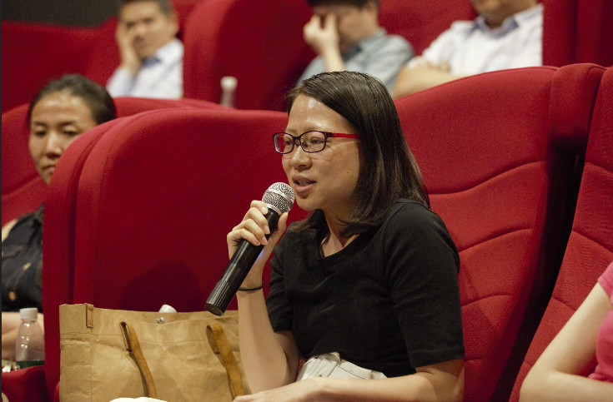

Judge Dai Yiting of the Beijing Higher People's Court held that the topic of cancer patients can’t afford for the drugs is indeed heavy, but from the perspective of patents, as the level of R&D of China's original research drugs continues to increase, it is necessary to discuss how to further strengthen Patent protection in the medical field. Promoting innovation through institutional design, and improving the overall strength and level of the domestic pharmaceutical industry is the fundamental solution to the problem.

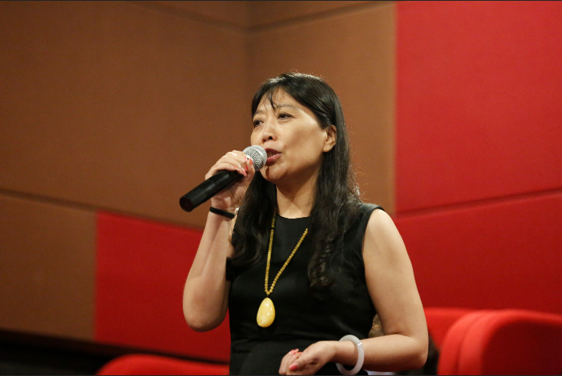

Ms. Li Hongtuan, director and partner of Beijing Sanju Sunshine Intellectual Property Agency Co., Ltd., said that for lawyers in the field of medicine, part of the lawyer's work is to help companies defend their rights and make innovation respected. On the other hand, it challenges patents and provides a small force for the development of generic drugs. In the future, I hope to see that China's pharmaceutical industry can strike a balance between protecting innovation and encouraging imitation. We must protect innovation, so that more companies are willing to invest in the development of new drugs, so that patients can have better life-saving drugs, and the price problem needs to be solved by ways and means.

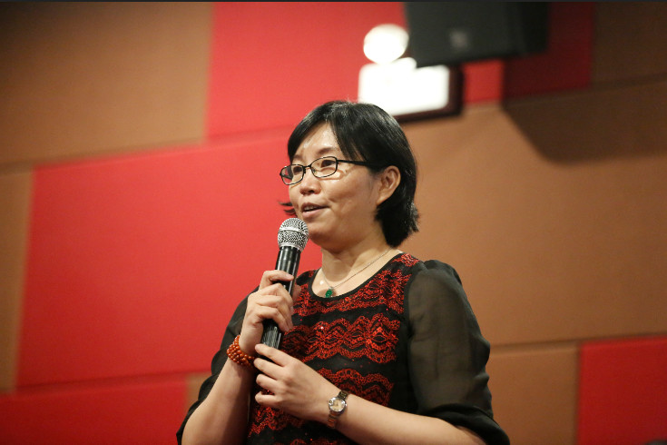

Ms. Duan Lihong, a senior partner of Beijing Tianchi Juntai Law Firm, combined with her past experience in trial work, said that in the trial of patent infringement cases involving drugs, the judge did not see the specific process of drug development, nor could he see the eyes of the patients eyes longing for life. When patents conflict with the right to life and health, whether we can find a better way out under the existing legal framework is a question we need to consider. In her view, on the issue of the right to life and health, you can try to use the patent compulsory license, or give the generic drug company more chances to legally challenge the original drug patent when the relevant legal basis is complete.

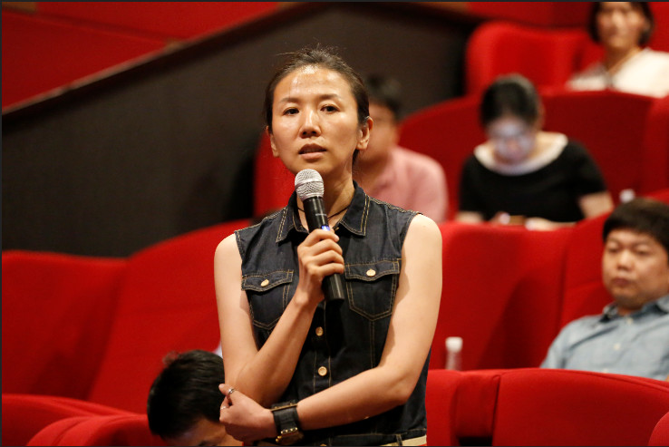

Judge Song Yanyan of the Beijing Intellectual Property Court believes that the problem of expensive drug prices reflected in the film "I am not a drug god" is not unique to China, but also in the early American films. Although the film ended in a happy ending, it also causes people to think deeply. In the process, if there is no such person as Cheng Yong or such an event happening, perhaps the road to reform and improvement of the relevant system will go a longer way. For the IP people, we need to have more social responsibility.

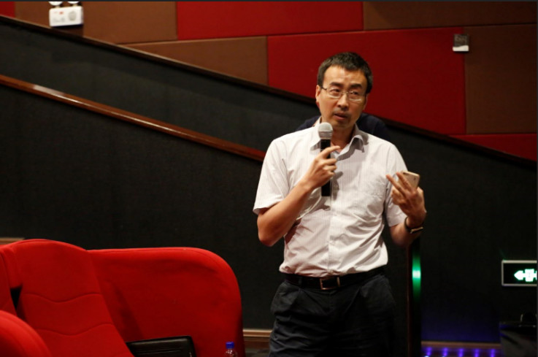

Associate Professor Cui Guobin, deputy dean of Tsinghua University Law School, said that since the discussion of AIDS patent drugs more than a decade ago, China’s discussion on patent compulsory licensing has always existed. The film reveals more about the fragile and contradictory aspects of human nature. The property rights system allows the right holder to price his own property, and must sacrifice the interests of those who cannot afford this price. This is the deadweight loss in economics. As far as the patent price is concerned, it is difficult for the government to know how much it is to sell. Therefore, in addition to maintaining the property mechanism, it is difficult to establish an effective pricing mechanism. Under the existing patent law framework, society can do very limitedly for "high-priced drugs." The society easily broke the commitment of the patent property system and saved the people in front of us. In fact, it is likely by doing so they have sacrificed more interests of those who we could have saved. In addition to the patent law, there may be tax, social assistance, government procurement and other ways to ease the problem.

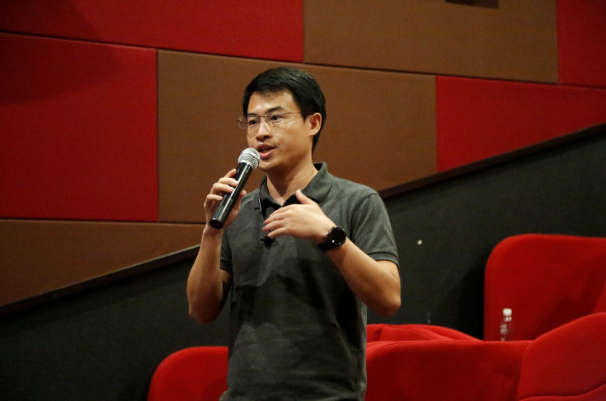

Judge Xu Bo of the Beijing Intellectual Property Court started from the cases he participated in, and discussed the competition between the original drug companies and generic drugs companies under the current drug registration and patent protection system in China. He also talked about his own opinions on the drug market after the expiration of the drug patent and related efforts made by the government, especially for the pricing and share of similar drugs in China and abroad.

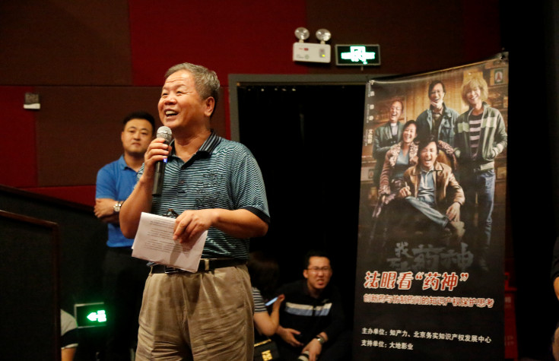

At the end of the event, Director Cheng Yongshun of BIPI first thanked Dadi Cinema for its strong support for this event. Director Cheng Yongshun emphasized that for patent protection of pharmaceuticals, encouraging innovation is the first priority, and it is necessary to give market incentives for innovative pharmaceutical companies for a certain period of time to encourage them to continuously develop new drugs. For rare drugs, orphan drugs should be given a longer period of protection. While encouraging imitation, the approval standards for generic drugs need to be strictly controlled to ensure that the quality of generic drugs is strictly consistent with the quality of the original drug.

After the event, the guests said that the activity model is novel, and the views of the speakers are very beneficial. They look forward to the next event.

