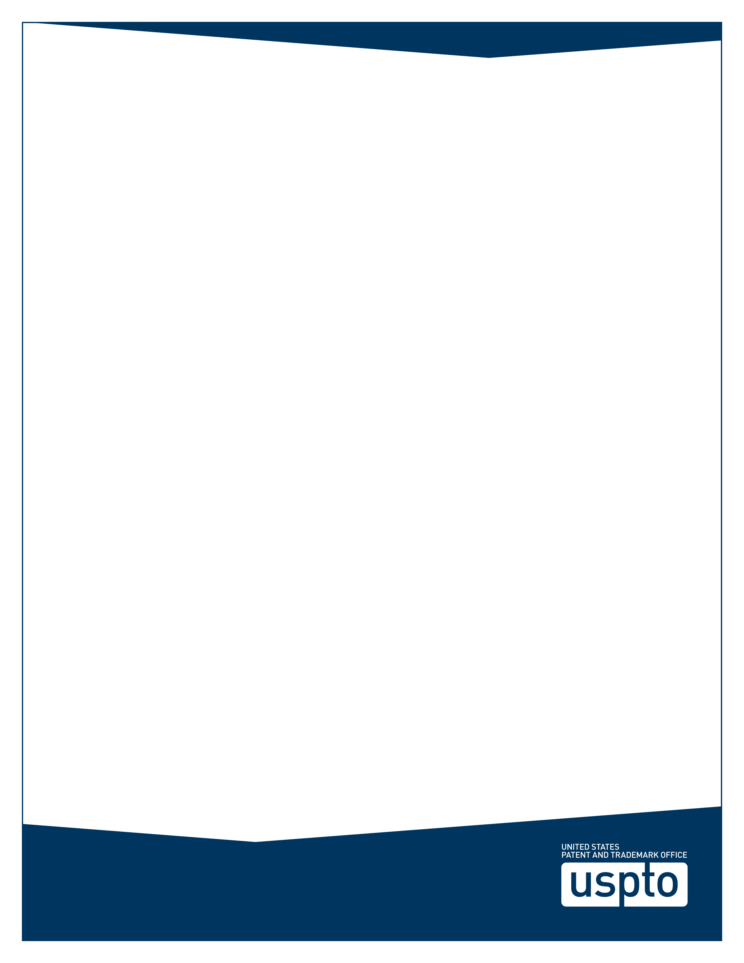
English Translation
of
Administrative Adjudication Measures for Drug Patent Dispute Early Resolution Mechanism
(Draft for Publication Opinions)

Article 1 The present measures are established according to the <<Patent Law of the People’s Republic of China>> and other related laws, rules, regulations in order to handle cases regarding administrative adjudication for drug patent disputes occurring when evaluating and approving drug marketing (simply referred to as drug patent dispute administrative adjudication hereinafter) according to the law.
Article 2 State Intellectual Property Office is responsible for handling the work related to administrative adjudication mentioned in Article 76 of the Patent Law.
Article 3 A case worker shall withdraw himself/herself from a case if he/or she has an interest relationship with a party concerned. The party concerned shall have the right to apply for withdrawal of the case worker. The party concerned shall provide reasons if such an application has been filed. The person in charge of the department handling the case shall make decision on withdrawal of the case worker.
Article 4 A party concerned shall meet the following conditions when requesting an administrative adjudication for a drug patent dispute:
(1) The requester is the patentee or a stakeholder of the corresponding patent and the applicant for the drug marketing authorization as mentioned in Article 76 of the Patent Law; the stakeholder is a licensee of the corresponding patent and the registered drug marketing authorization holder;
(2) There is a clear requestee;
(3) There are clear requested items and detailed facts, reasons;
(4) The related patent information has been validly registered on the China’s marketed drug patent information registration platform, and the patent type complies with the related regulations of <<Implementing Measures for Drug Patent Dispute Early Resolution Mechanism>>;
(5) The party concerned has never filed a lawsuit regarding this drug patent dispute to a People’s Court or such case has never been accepted by a People’s Court.
Article 5 It is necessary to submit a request and the following materials in order to request the State Intellectual Property Office to make an administrative adjudication for a drug patent dispute:
(1) Subject qualification certificate.
(2) The information registered for the related patent on the China’s marketed drug patent information registration platform, an application for drug marketing authorization publicized in the information platform of the National Drug Evaluation Agency and a claim of not falling within the patent right protection scope of the related patent.
(3) If the requester is the applicant for the drug marketing authorization, the requester shall also provide the technical scheme related to the drug applied for registration. The technical scheme shall be independently submitted and claimed if it involves confidential information.
Article 6 The request shall state the following contents:
(1) Name or title, address of the requester, name, telephone number of the legal representative or person in charge, name, address, telephone number of the appointed agent, agent, and agency.
(2) Name or title, address of the requestee, name, telephone number, and other items of the legal representative.
(3) Information of the related patent registered on the China’s marketed drug information registration platform, including patent number, patent type, patent status, patentee, expiration date of the patent protection period, and the Claims requested to determine whether they fall within the protection scope.
(4) The related information and the type claimed of the drug applied for registration publicized in the information platform of the National Drug Evaluation Agency.
(5) Reasons regarding whether the technical scheme of the drug applied for registration falls within the protection scope of the patent concerned.
(6) List of the evidences.
(7) Signature (natural person) or stamp (legal person or other organization) of the requester or a specially authorized agent. The related evidence and proof materials can be submitted as a request attachment.
Article 7 After receiving the request and the related materials, the State Intellectual Property Office shall register and examine the request and other materials. If the request and the related materials are incomplete, the State Intellectual Property Office shall notify the requester to submit the complete materials within a specified period of time.
A drug patent dispute administrative adjudication request is deemed not submitted if it falls under any of the following circumstances:
(1) The request is not filled in a prescribed format or the request is not filled according to the regulations;
(2) The requester fails to submit the evidences according to the regulations.
Article 8 The State Intellectual Property Office does not accept a drug patent dispute administrative adjudication request and will notify the requester if the request falls under any of the following circumstances:
(1) The name or tile, address, or other basic information of the requester is missing in the request, or the patent right information is missing in the request;
(2) The requestee is unclear;
(3) The patent concerned does not belong to the patent subject types registered on the China’s marketed drug information registration platform, or the patent concerned does not match the patent claimed in the fourth type of declaration;
(4) The Claims of the patent concerned are declared to be invalid.
Article 9 The State Intellectual Property Office shall establish a case and notify the requester and the requestee within a specified period of time if the request submitted by the party concerned meets the conditions of article 4.
Article 10 If needed, the State Intellectual Property Office may verify the evidences concerned with a drug administration department.
Article 11 The State Intellectual Property Office may choose a written trial or an oral trial based on the request submitted by the party concerned and the case situation.
If an oral trail is chosen, the State Intellectual Property Office shall notify the party concerned of the time and location of the oral trail at least three working days prior to the oral trial. The request is deemed to be withdrawn if the requester fails to attend the trial without a proper reason or exit the trail halfway without permission; an absent trail will be conducted if the requestee fails to attend the trial without a proper reason or exit the trail halfway without permission.
Article 12 During processing of a drug patent dispute administrative adjudication case, if some of the Claims of the patent concerned are declared to be invalid, the State Intellectual Property Office will make an administrative adjudication based on the Claims remained valid; if all the Claims of the patent concerned are declared to be invalid, the State Intellectual Property Office will reject the request on the administrative adjudication.
Article 13 When processing a drug patent dispute administrative adjudication case, the State Intellectual Property Office may conduct mediation as wished by the parties concerned. If the parties concerned reach an agreement as a result of the mediation, the State Intellectual Property Office may provide a mediation agreement as requested by the parties concerned. If no agreement is reached as a result of the mediation, the State Intellectual Property Office shall make an administrative adjudication without delay.
Article 14 Under any of the following circumstances, the party concerned may apply to halt processing of a case; the State Intellectual Property Office may also decide to halt processing of the case on its own initiative.
(1) Either party concerned deceased, and it is necessary to wait for expression of his/her inheritor’s willingness about whether to continue with the processing of the case;
(2) Either party concerned is incapacitated of requesting administrative adjudication and has not yet appointed a legal representative;
(3) The legal person or other organization of either party concerned terminated and has not identified a successor to rights and obligations;
(4) Either party is unable to attend the trial due to force majeure;
(5) Other situations when the case shall be halted.
Article 15 The requester may withdraw the request before the State Intellectual Property Office before makes an administrative adjudication. The validness of the administrative adjudication is not affected if the requester withdraws the request after the conclusion of the administrative adjudication has been declared or a written adjudication has been sent out.
The procedure of the drug patent dispute administrative adjudication is terminated if the requester withdraws the request or the request is deemed to be withdrawn.
Article 16 When making an administrative adjudication, the State Intellectual Property Office shall determine whether the technical scheme of the drug applied for marketing falls within the patent right protection scope of the patent concerned and explain the reasons and evidences.
An administrative adjudication shall be publicized to the society according to the related regulations after being made.
Article 17 If the party concerned refuses to accept the administrative adjudication made by the State Intellectual Property Office, he/she may file a lawsuit to a People’s Court within fifteen days after receiving the administrative adjudication decision.
Article 18 The party concerned is responsible for the authenticity of the evidences or proof materials provided by this party.
The party concerned is obligated to keep the commercial secrets obtained during the administrative adjudication procedure confidential and shall be held liable if disclosing, using, or allowing a third party to use the commercial secretes without permission.
Article 19 For any case worker handling a drug patent dispute administrative adjudication and other staff members who abuse his/her power, neglect his/her duty, practice favoritism and engage in malpractice, or reveal commercial secrets obtained during case handling, if a crime is constituted, he/she shall be subject to criminal liabilities; if no crime is constituted, administrative sanctions shall be imposed according to the law.
Article 20 In case there are no corresponding provisions in the present measures, the relevant provisions of <<Measures for Administrative Enforcement of Patents>> and other provisions of the State Intellectual Property Office regarding patent infringement dispute administrative adjudication shall be implemented.
Article 21 The State Intellectual Property Office is responsible for interpreting the present measures.
Article 22 The present measures will be implemented starting from June 1, 2021.

THE USPTO IS PROVIDING THIS TRANSLATION SOLELY AS A CONVENIENCE TO THE ENGLISH-READING PUBLIC. WE HAVE ATTEMPTED TO PROVIDE AN ACCURATE ENGLISH TRANSLATION OF THE CHINESE DOCUMENT, BUT DUE TO THE NUANCES IN TRANSLATING FROM CHINESE TO ENGLISH, SLIGHT DIFFERENCES MAY EXIST. WE WILL MAKE EVERY EFFORT TO CORRECT ERRORS BROUGHT TO OUR ATTENTION.

